Q.1 How many students from various cities? (Solve using data visualisation tool).

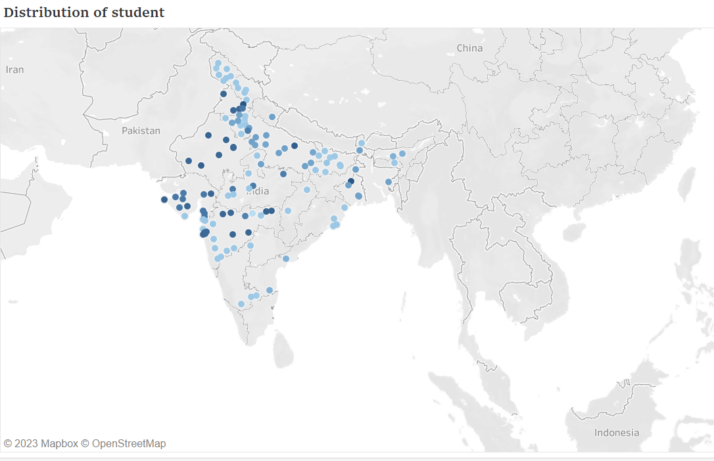

Q.2 Which event tend to attract more students from specific fields of study?

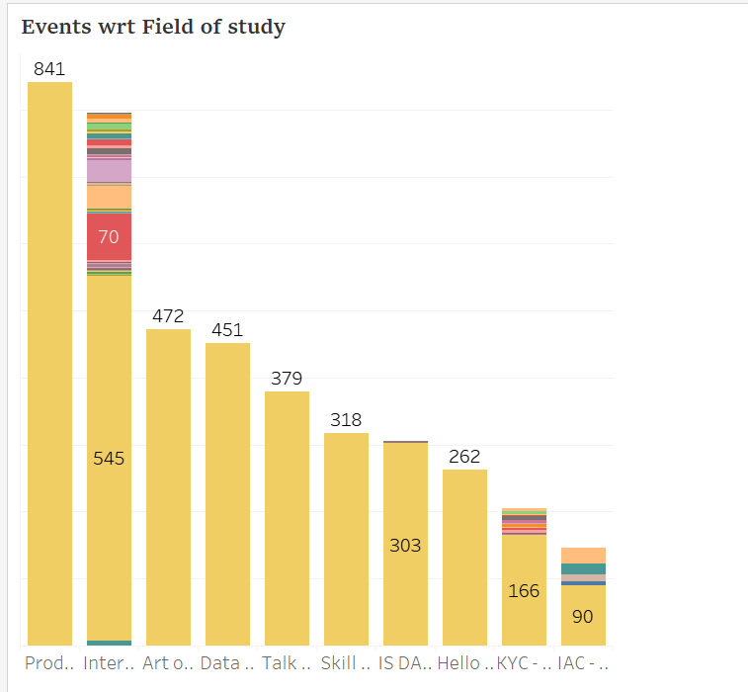

Q.3 Do students in leadership positions during their college years tend to have higher GPAs or better expected salary?

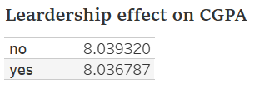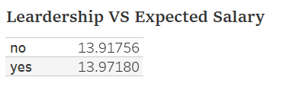

Q.4 How many students are graduating by the end of 2024?

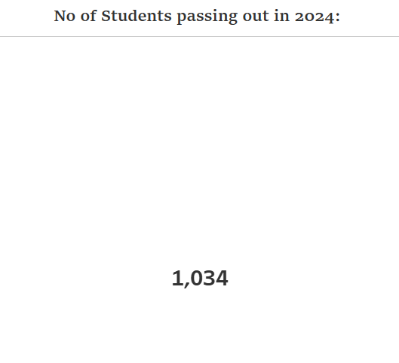

Q.5 Which promotion channel brings in more student participations for the event?

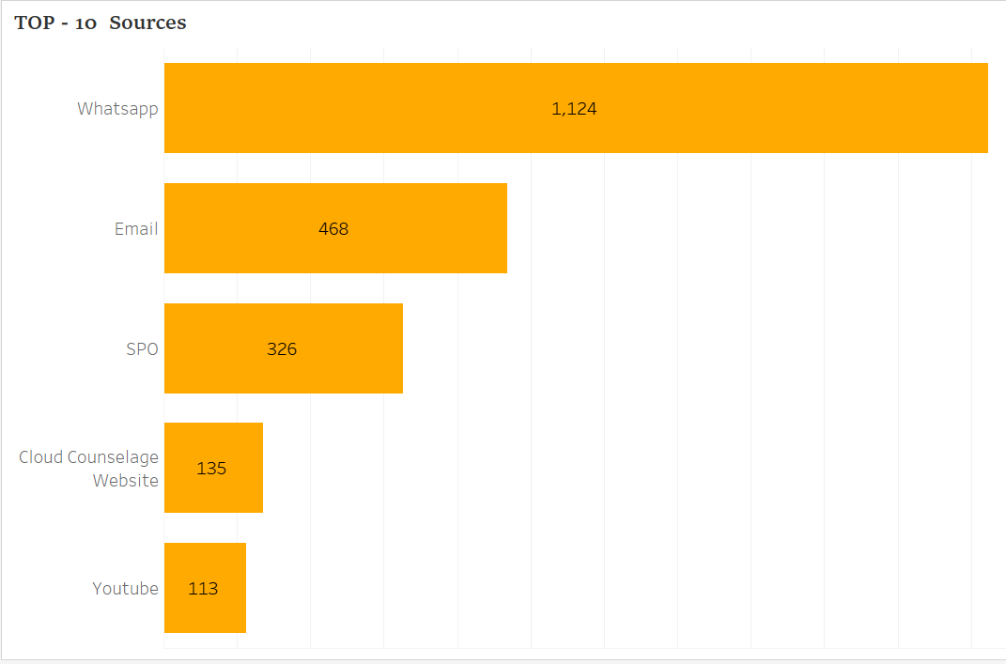

Q.6 Find the total number of students who attended the events related to Data Science? (From all Data Science related courses.)

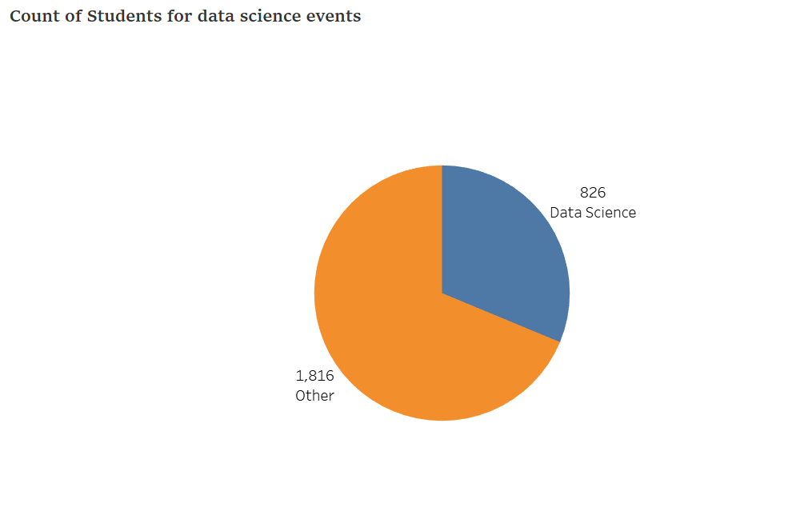

Q.7 How many students know about the event from their colleges? Which of these Top 5 colleges?

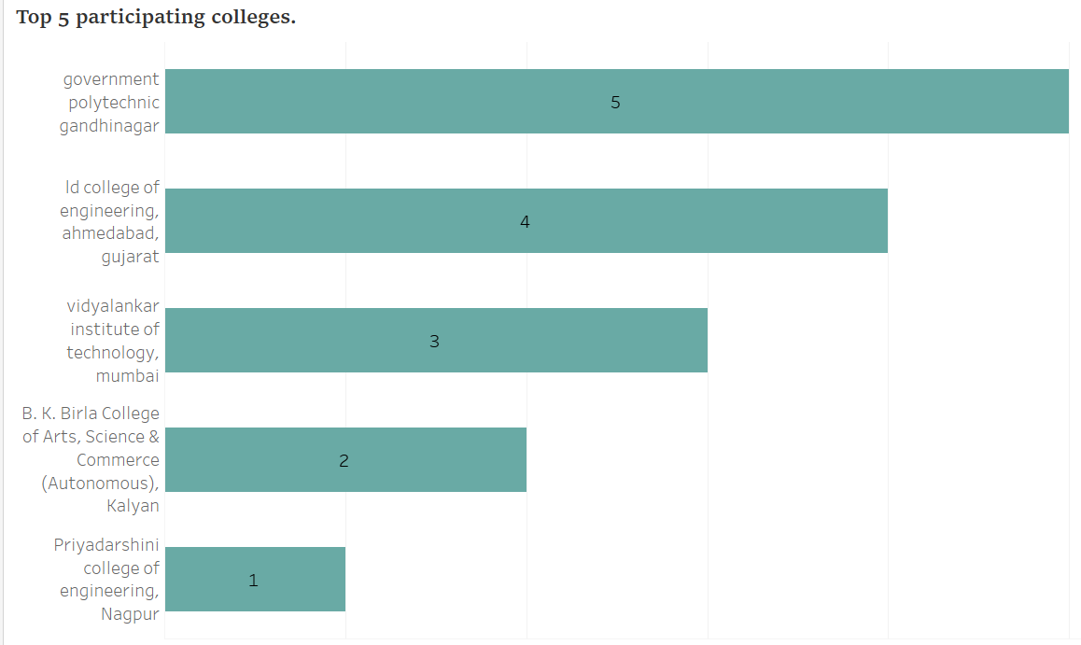

Dashboard:

